ATTACH

STUDENT**'**S

PHOTOGRAPH

HERE

The Principal,

PINEWOODS INTERNATIONAL HIGH SCHOOL & JUNIOR COLLEGE

PANCHGANI 412 805.

Maharashtra, INDIA.

Phone: 02168 – 240900, 240901, 240902.

District & State:

1

Particulars of the candidate to be filled in BLOCK LETTERS ONLY.

Date of Birth -

Attach Xerox Copy

of Birth Certificate

Name in Full -

(In Block Letters)

In words:

Surname:

Child’s Name:

Father’s Name:

In figures:

Place of Birth:

I / We undertake to pay the Fees on admission. After admission if my son / daughter is unable to

A adjust to the institution, the **FEES IS NOT REFUNDABLE** under any circumstances. Full Term fee is charged,

irrirrespective of the fact when the pupil joins the institution.

**FEES ARE NOT REFUNDED IF THE CHILD IS WITHDRAWN IN THE MIDDLE OF THE ACADEMIC YEAR**.

I am aware that in case my son/ward is not joining in the new academic year, notice of **withdrawal is to be submitted to the college by January 15th.** If the notice of withdrawal is submitted after January 15th to the college then a notice fee of **Rs. 50,000/-** will be charged.

I am also aware that there is a fine of Rs.100/- per day on fees not being paid on time.

**All legal matters concerning students and student-related cases are subject to Wai jurisdiction.**

Dear Sir / Madam,

I / We desire that my / our _________ may be admitted to the **SCHOOL DIVISION** **(ICSE/SSC SYLLABUS**)

OF PINEWOODS INTERNATIONAL HIGH SCHOOL & JUNIOR COLLEGE, PANCHGANI.

**I / We have carefully read the Prospectus & Website containing the Rules and Regulations, Terms and Conditions and Requirements of the Institution and I / we hereby agree to abide by them.**

I / We also agree to the all the Rules and Regulations, Terms and Conditions and Requirements of the Institution mentioned in the Prospectus & Website.

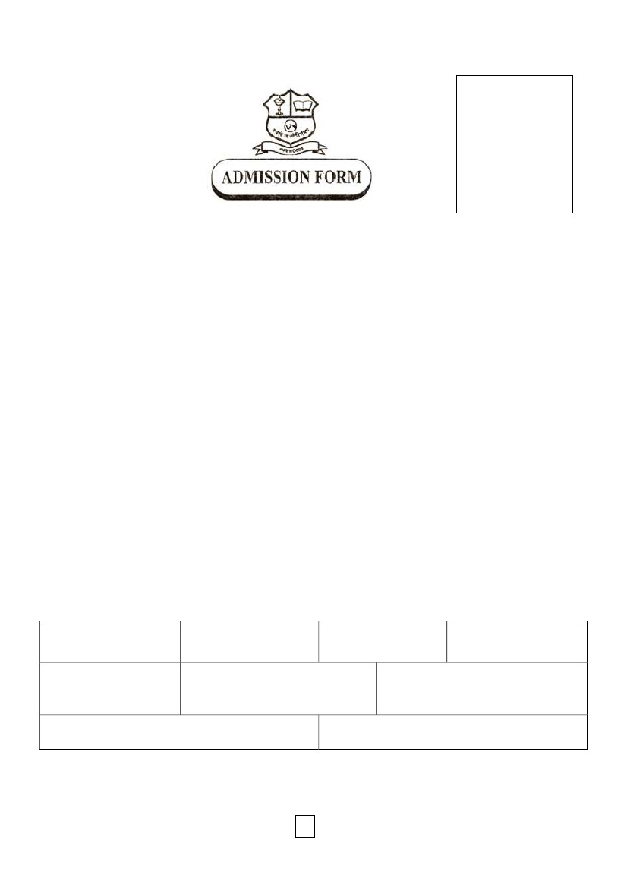

**Religion**

________________________________ **Mother Tongue** __________________________________

**Seeking admission in** **STD** ____of the **SCHOOL DIVISION**

.

_________________________________________________________________________________________

**Medium of Instruction** _______________________________________________________________________

**Standard Completed** ________________________ **Year** ___________________________________________

**Name of Parent/Legal Guardian** _______________________________________________________________

__________________________________________________________________________________________

**Yearly Income** **_____________________________ Occupation** _____________________________________

**I have read the Prospectus and agree to abide by the all the rule in all respect, and also accept that they may**

**be changed from time to time without notice**.

**Date** _______________________

**Signature of Father/ Mother/ Legal Guardian**

FOR OFFICE USE ONLY:

Admission test conducted on

Admission Granted in Grade

Academic Year

Papers Submitted

1. ________________________________________________________________________________

2. ________________________________________________________________________________

3. ________________________________________________________________________________

4. ________________________________________________________________________________

2



**Dormitory** NORMAL/SPECIAL ____________________________

**Nationality** _______________________________ **Passport No**. _____________________________________

**Name of the passing out** **School and Board** _______________________________________________________

**Full address of the passing out school**  _________________________________________________________

**IMPORTANT:**

**ON CONFIRMATION OF ADMISSION PLEASE PROVIDE THE FOLLOWING:**

**1) MARK SHEET OF ANNUAL EXAMINATIONS**

**2) ORIGINAL COPY OF THE LEAVING CERTIFICATE FROM THE SCHOOL. (THE CERTIFICATE SHOULD BE**

**ATTESTED BY THE EDUCATION OFFICER.)**

**PINEWOODS INTERNATIONAL HIGH SCHOOL & JUNIOR COLLEGE, PANCHGANI.**

**(All Details to be filled in Complete)**

**FILL IN THE FOLLOWING FORM IN CAPITAL LETTERS**.

NAME OF STUDENT: __________________________________________________________________________

FATHER’S FIRST NAME: _______________________________________________________________________

FATHER’S MIDDLE NAME: ______________________________________________________________________

FATHER’S LAST NAME: ________________________________________________________________________

MOTHER’S FIRST NAME: _______________________________________________________________________

MOTHER’S MIDDLE NAME: _____________________________________________________________________

FULL RESIDENCE ADDRESS WITH PINCODE:

___________________________________________________________________________________________

___________________________________________________________________________________________

PHONE NO. OF RESIDENCE: __________________________________________________________________

MOBILE NO. OF FATHER ___________________________________________________________________

EMAIL ID OF FATHER ___________________________________________________________________

MOBILE NO. OF MOTHER ___________________________________________________________________

EMAIL ID OF MOTHER ___________________________________________________________________

FULL OFFICE ADDRESS WITH PINCODE:

___________________________________________________________________________________________

___________________________________________________________________________________________

PHONE NO. / FAX NO. OF OFFICE: ______________________________________________________________

PERMANENT ADDRESS:

___________________________________________________________________________________________

___________________________________________________________________________________________

NAME OF RELATIVE & FULL ADDRESS WITH PINCODE:

___________________________________________________________________________________________

___________________________________________________________________________________________

RELATIVES’ PHONE NO.: ______________________________________________________________________

RELATIVES’ MOBILE NO.: ______________________________________________________________________

RELATIVES’ E-MAIL ID ________________________________________________________________________

Signature of: **___________________**

**Father**

**___________________**

**Mother**

3

**__________________**

**Legal Guardian**



Declaration to be signed by Parent / Guardian at the time of admission.

1) I _____________________________________________________________(Full Name of Parent) Parent /guardian of

__________________________________________________(full Name of Student) have carefully, read the PINEWOODS

INTERNATIONAL HIGH SCHOOL & JUNIOR COLLEGE’S prospectus and I accept the terms. Conditions, principles

and procedures on which the institution functions and agree to abide by all the rules and regulations (or any

substitutions for or modifications in them, which may be made by the school authorities from time to time).

I shall particularly carry out the rules and procedure regarding the payment of the fees and other dues, fully

accept the Principal’s absolute discretion and decision in the matter of discipline, promotion and admission of

students. . I agree to pay for any damage caused by my child/ward to the movable and immovable property of the institution.

2) Fully realizing that in the course of normal life and the many-sided and strenuous training given in the

institution particularly in physical activities and excursions and trips, accident are likely to occur, resulting

sometimes in serious damage to life and limb, I hereby absolve the institution of all reasonability in case such

accident or accidents befall on my son / daughter / ward in this institution after making sure of its capability in

taking normal precautions.

3)**Fees and other charges are liable to be revised at any time. Full Term fee is charged, irrespective of the fact**

**when the pupil joins the institution.**

**I specifically accept the conditions that the name of my son / daughter / ward is liable to be removed from**

**the roll and the student to be sent home if the payment of fees falls in arrears for more than two months from**

**the date of bill. I also agree to the term of fine of Rs.100/- per day in case I do not pay the fees within**

**stipulated period. also agree that my child will not be permitted to appear in the examinations if dues are not cleared.**

4) I accept the Principal’s absolute discretion in the regard to who is to be allowed to meet my son / daughter/ward

during term time, where he / she is to be allowed to go or visit whilst he / she is at institution and what

personal expenditure he / she is to be allowed. I agree that the institution may give or get for my son / daughter / ward

any article urgently required by him/her and that bill for such articles will be sent to me.

5) I understand that the school maintains the right to remove / rusticate a student at any time and without

reconsideration or appeal for low academic achievement or if the student fails to conform to the standards or

discipline set by the institution.

6) With regard to complaints of any kind, if any, I shall meet the School Authorities in the Office only and not the Class

Teacher or any other Teacher/Warden.

7) I have read the prospectus / visited the website, read all the rules and I am bound by all the rules of the

institution and will abide by them. **I will be responsible if my child/ward brings things that are not permitted to the school.**

8) I am fully aware that boys / girls are not admitted on trial and that fees once paid will not be refunded.

**FEES ARE NOT REFUNDED IF THE CHILD IS WITHDRAWN IN THE MIDDLE OF THE ACADEMIC YEAR.**

**I am aware that in case my son/ward is not joining in the new academic year, notice of withdrawal is to be**

**Submitted to the school by January 15th. If the notice of withdrawal is submitted after January 15th to the school then a notice fee of Rs. 50,000 will be charged.**

9) All legal matters concerning students and student-related cases are subject to Wai jurisdiction.

PINEWOODS INTERNATIONAL HIGH SCHOOL & JUNIOR COLLEGE

PANCHGANI 421 805, Maharashtra, INDIA.

FORM B

Attach

Photograph

Here

Attach

Photograph

Here

Attach

Photograph

Here

**MOTHER**

**FATHER**

**GUARDIAN**

Date __________

___________________

**Mother**

4

____________

**Father**

________________

**Legal Guardian**



**PINEWOODS INTERNATIONAL HIGH SCHOOL & JUNIOR COLLEGE**

**PANCHGANI 412 805, Maharashtra, INDIA.**

**FORM C**

**Certificate of General Health**

(**To be filled in and signed by the Medical Officer**)

A. This is to certify that I have examined today Master / Miss __________________________________

__________________________________________aged ______________________________and I

Find that he/she is not suffering from any infectious or contagious disease and that he/she is physically

fit in all respects to attend the boarding and to take part in all its activities.

1. (a) Height __________________ (b) Weight ___________________ (c) Chest _________________

2. Identification Marks (i) _____________________________ (ii) ______________________________

## 3. (a) Measles-Rubella (MR) Vaccine taken on :___________ (Attach Certificate)

(b) **NASOVAC*-S* Influenza Vaccine taken on**:___________ **(Attach Certificate)**

4. Record after each disease given below with (+) for positive and (-) for negative, Depending

whether the boy/girl has suffered from it or not :

I)

III)

V)

VII)

IX)

XI)

Rheumatic fever

Typhoid

Measles

Diphtheria

Worms

Asthma

II)

IV)

VI)

VIII)

X)

XII)

Malaria

Enuresis

Nephritis

Mental retardation

Poliomyelitis

Dysentery

5. Other Information:

i) Eyes: Refractive Error / Trachoma

ii) Ears: Any discharge / disease / deafness

iii) Nose: Epitasis – D.V.S.

iv) Tonsils: Chronic Enlargement

v) G.I.T. – Appendicle Colic/Any other colic

vi) Hernia / Hydrocephalus

vii) Phimosis

6. Any injury, illness or operation during the last two years? Date? _______

7. Allergy to drugs: Penicillin, Sulfa group, Quinine, Chloramphenicol and any other drug.

8. **Blood group ________________________________**

9. **Report of G6PD Blood Test & CBC (Complete Blood Count) to be enclosed.**

Name of the Doctor _____________________________________________________________

Address _____________________________________________________________________________

**Signature / Seal of the Doctor**

**Date:**

5

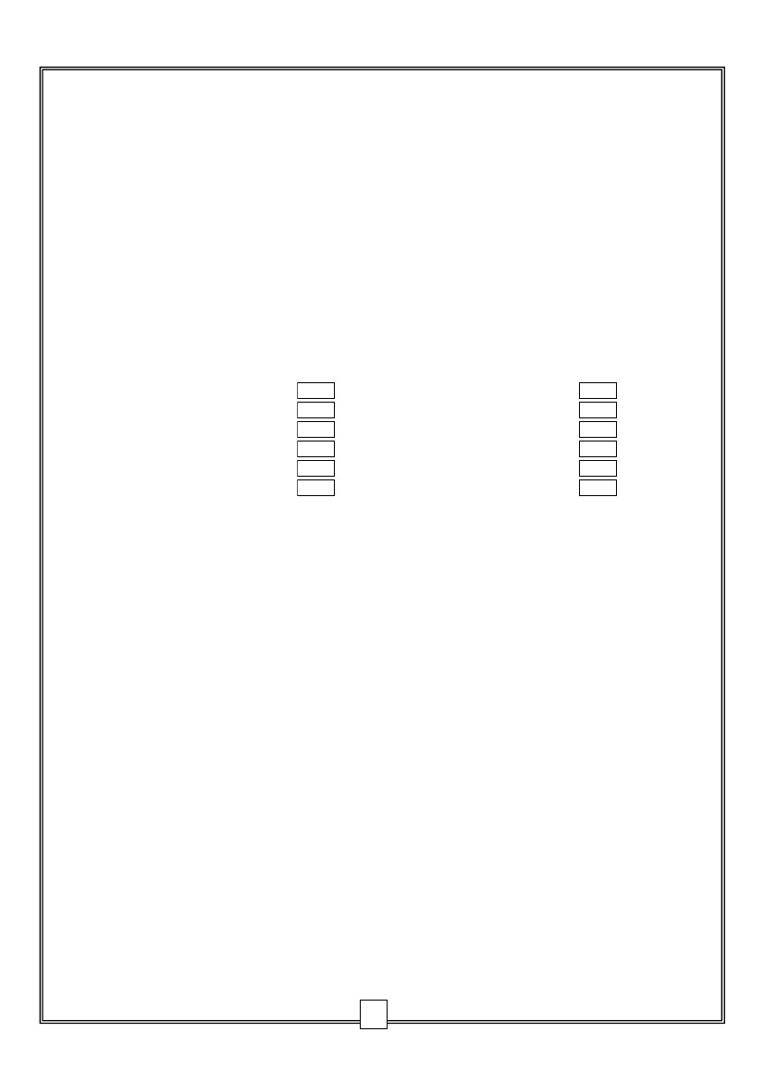

**PINEWOODS INTERNATIONAL HIGH SCHOOL & JUNIOR COLLEGE, PANCHGANI.**

**Certificate of General Health**

A. This is to certify that I have examined Master / Miss ____________________________

_______________________________________________ aged _______________________

and I find that he / she is not suffering from any infectious or contagious disease and that

he / she is physically fit in all respect to attend a boarding institution and to take part in

all its activities.

**Date of Inoculation (Attach Certificate)**

B. **The following vaccinations / inoculations are COMPULSARY:**

**Disease**

a) Measles-Rubella (MR)

b) Typhoid

c) NASOVAC-S Influenza

d) Hepatitis B

**Signature / Seal of Doctor**

**Date:**

**6**

**PINEWOODS INTERNATIONAL HIGH SCHOOL & JUNIOR COLLEGE, PANCHGANI.**

**FOR FOREIGN STUDENTS ONLY**

Name in Capital (As it appears in the PASSPORT) ____________________________________________________________

Present Nationality_____________________________________________

PASSPORT PARTICULARS VISA PARTICULARS

No.____________________ 1. No. ________________________

Issued at ________________ 2. Issued at _____________________

Issued on ________________ 3. Issued on ____________________

Valid till _________________ 4. Visa for India

Valid till ______________________

Date and Place of arrival in India _________________________________

Name of Vessel / Airline on which ________________________________

arrived in India.

Address of last residence outside India ____________________________

___________________________________________________________

**PLEASE NOTE ADMISSION WILL BE GRANTED ONLY ON STUDENT’S VISA.**

**NAME AND DETAILS OF GUARDIAN IN INDIA:**

Full Name __________________________________________________

Occupation _________________________________________________

Residential Address __________________________________________

Phone No. ___________________ Mobile No. ______________________

E-Mail ID ____________________________________________________

Office Address________________________________________________ ____________________________________________________________

Office Phone No. ______________ Office E-Mail ID __________________

**Date: _________** **_____________ _____________ _____________**

**MOTHER** **FATHER**  **GUARDIAN**

**7**